Database Design:

In this area we created the QuickMeds MySQL database for a straightforward web data framework for Neighbourhood Drug store administration extend. The database is utilized to sort out and keep up vital client, medicine, and me. Customer, Medicine, and prescription make up its three essential tables. Those all tables are associated by outside keys to protect information judgment and encourage successful information organization.

Individual customer information is stored in the client’s database, inventory and expenses are tracked in the medications table, and references to both clients and medications are contained in the medicines table. This method ensures that there is a clear relationship between who uses what material and when.  
  
Entity-Relationship Diagram (ERD):

The ER diagram show the one-to-many relationships between customers and prescription and between medicines and prescription.

Here is the screenshots of ERD:

SQL code for creating the table

SQL code for creating customer table:

Screenshot:

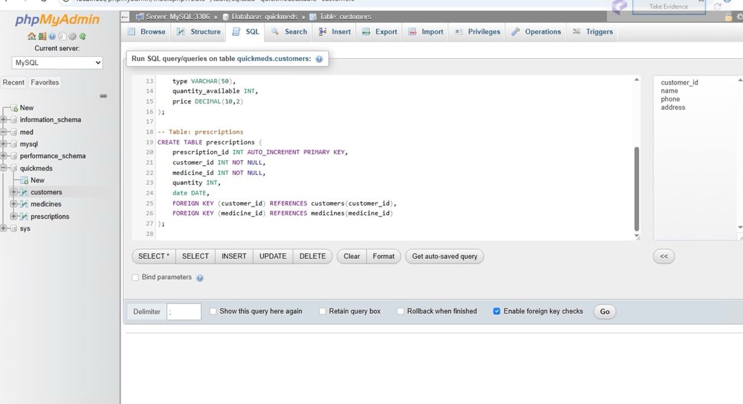

SQL code for creating Medicine table:   
  
Screenshot:

SQL code for creating prescription tables:

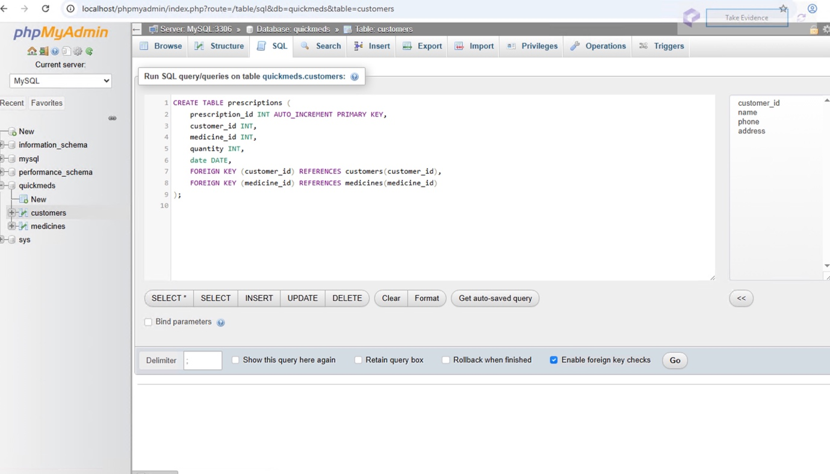

After PHP code to create customer table in phpMyAdmin.

Here is the screenshot of customer table in phpMyAdmin.

